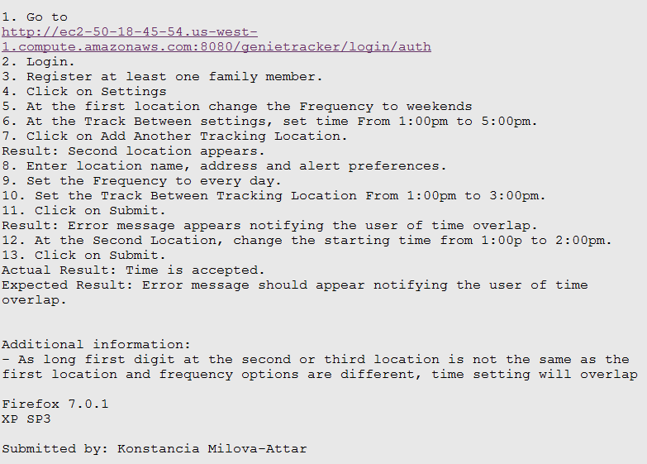

1. G0 to

1 . comnute . amazonaws . com: 8 080/genietracker/login/auth

Login.

. Register at least one family member.

Click on Settings

At the first location change the Frequency to weekends

At the Track Between settings, set time From 1:00pm to 5:00pm.

. Click on Add Another Tracking Location.

Result: Second location appears.

8. Enter location name, address and alert preferences.

9. Set the Frequency to every day.

10. Set the Track Between Tracking Location From 1:00pm to 3:00pm.

11. Click on Submit.

Result: Error message appears notifying the user of time overlap.

12. At the Second Location, change the starting time from 1:00p to 2:00pm. 13. Click on Submit.

Actual Result: Time is accepted.

Expected Result: Error message should appear notifying the user of time overlap.

Additional information: — As long first digit at the second or third location is not the same as the first location and frequency options are different, time setting overlap

Firefox 7.0.1 XP SP3

Submitted by: Konstancia Milova—Attar