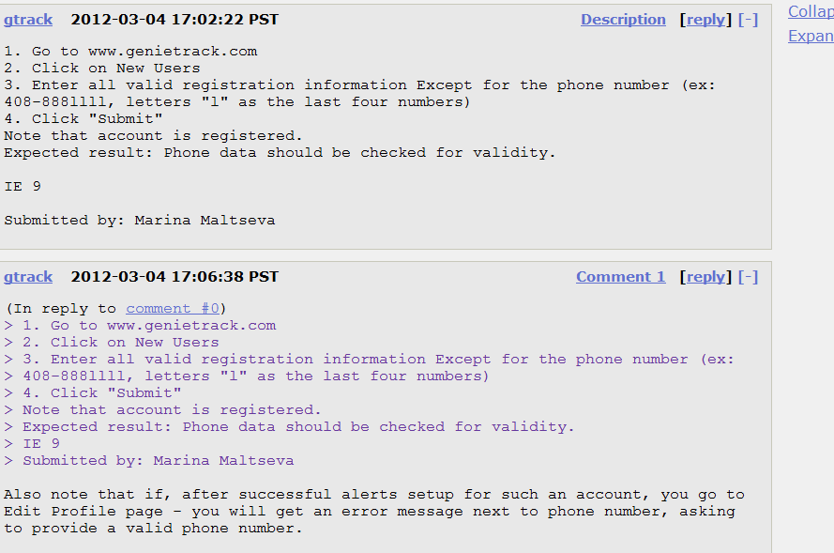

**gtrack 2012-03-04 17:02:22 PST Descrigtion [reply]**

1. Go to www.genietrack.com

2. Click on New Users

3. Enter all valid registration information Except for the phone number (ex: 408—888llll, letters "l" as the last four numbers)

4. Click "Submit"

Note that account is registered.

Expected result: Phone data should be checked for validity.

Submitted by: Marina Maltseva

gtrack 2012-03-04 17:06:38 PST Comment 1 [reply] (In reply to comment i O)

1. Go to mm.genietrack.com

2. Click on New Users

3. Enter all valid registration information Except for the phone numb 408—888llll, letters as the last four numbers)

4. Click "Submit"

Note that account is registered.

Expected result: Phone data should be checked for validity.

Submitted by: Marina Maltseva

Also note that if, after successful alerts setup for such an account, you go to Edit Profile page you will get an error message next to phone number, asking to provide a valid phone number.