nAndroid Virtual Device

Mac OSX 10.8.2 (MountainLion)

1. To download android sdk go to

<http://developer.android.com/sdk/index.html>

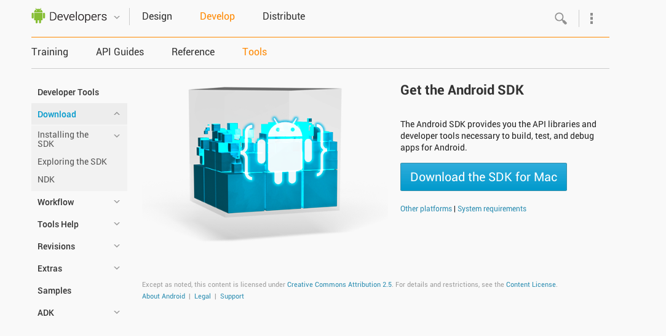

1. Click on “**Download SDK For Mac**”
2. The download would start automatically and stored in your default “download” folder. ( Check your settings for where it is directed to)
3. It would be in zip format. Unzip the file (android-sdk-macosx) if not done automatically.
4. Move the unzipped folder to a desirable location. By doing this we get the basic package. But we need to install a platform as android has so many different platforms and devices. To do that
   1. Launch the Terminal.
   2. Execute the following command :

**/Users/mohanty/Desktop/android-sdk-macosx/tools/android ; exit;**

this command would be different for everybody.

what it is the complete path of till “android” exec file in the tool.

* 1. This would launch the following screen that gives the list of all the platforms available with the latest one checked and rather than saying installed it would be **“install”.**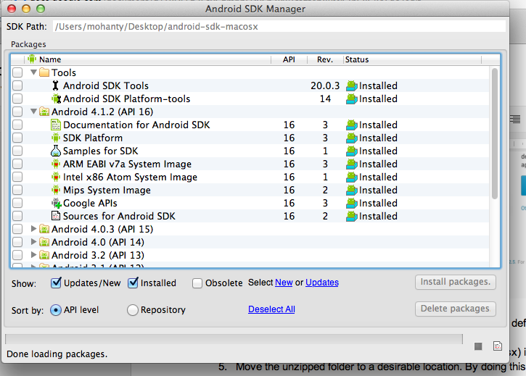
  2. Click on “install package” and wait.
  3. Once its completed the android sdk is installed. Quit the terminal.

1. Now that we have installed the sdk, we need to install emulator, or the android virtual device. To do that.
   1. relaunch the terminal and we need to figure out the target to install as there are so many options.
   2. execute the following command to find out the targets available **/Users/mohanty/Desktop/android-sdk-macosx/tools/android list targets**

again this would be different for individual user depending on the location of unzipped file.

* 1. The **android** tool scans the **<sdk>/platforms/** and **<sdk>/add-ons/**directories looking for valid system images and then generates the list of targets. Here's an example of the command output:

**id: 1 or "android-16"**

**Name: Android 4.1.2**

**Type: Platform**

**API level: 16**

**Revision: 3**

**Skins: HVGA, QVGA, WQVGA400, WQVGA432, WSVGA, WVGA800 (default), WVGA854, WXGA720, WXGA800, WXGA800-7in**

**ABIs : armeabi-v7a, mips, x86**

* 1. the available target is “ id 1” with 3 options for ABIs so the command line version of installing avd would be to run the following command

**/Users/mohanty/Desktop/android-sdk-macosx/tools/android create avd -n my_android -t 1 --abi armeabi-v7a**

* 1. the **android** tool next asks you whether you want to create a custom hardware profile.

**Android 4.1.2 is a basic Android platform.**

**Do you wish to create a custom hardware profile [no]**

use the default hardware emulation options for the AVD, just press the return key (the default is "no").

* 1. that would create the default emulator and give the following message

**Created AVD 'my_android' based on Android 4.1.2, ARM (armeabi-v7a) processor,**

**with the following hardware config:**

**hw.lcd.density=240**

**vm.heapSize=48**

**hw.ramSize=512**

* 1. To open the android emulator execute the following command

**/Users/mohanty/Desktop/android-sdk-macosx/tools/android avd**

this would open the screen with list of all the AVD you have created

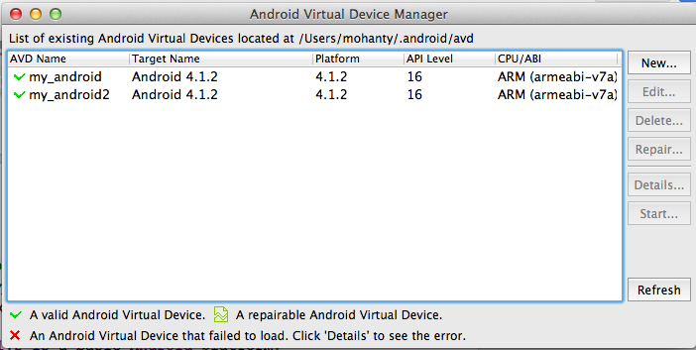

* 1. Select the emulator you want to open and click on start.
  2. that would open the emulator

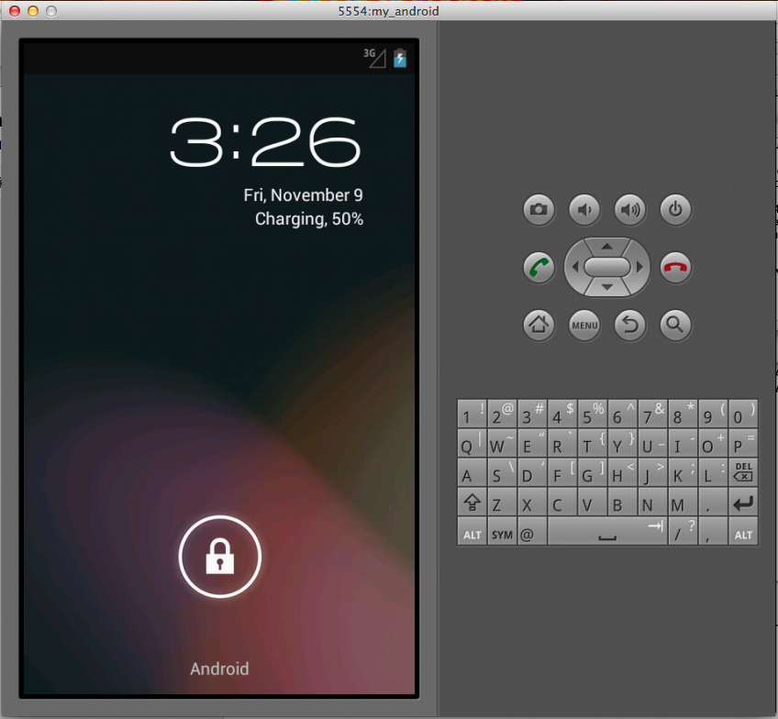

1. To close the emulator just close the emulator screen by clicking on the red button and the screen with emulator list.
2. Now that our emulator is all set we need to load our application. To do so please follow the following steps.
   1. Login to [casunstudio@gmail.com](mailto:casunstudio@gmail.com) account and go to google drive and open the document <https://docs.google.com/file/d/0B8LbFB2Er67EZHlUUzhFekhDbDg/edit>
   2. Download the GenietrackLocator.apk file and move it to a desirable location.
   3. Launch the Terminal and navigate to Platform tools in the android-sdk-macosx folder using the “cd” command and execute the following command

./adb install /Users/mohanty/Desktop/GenietrackLocator.apk