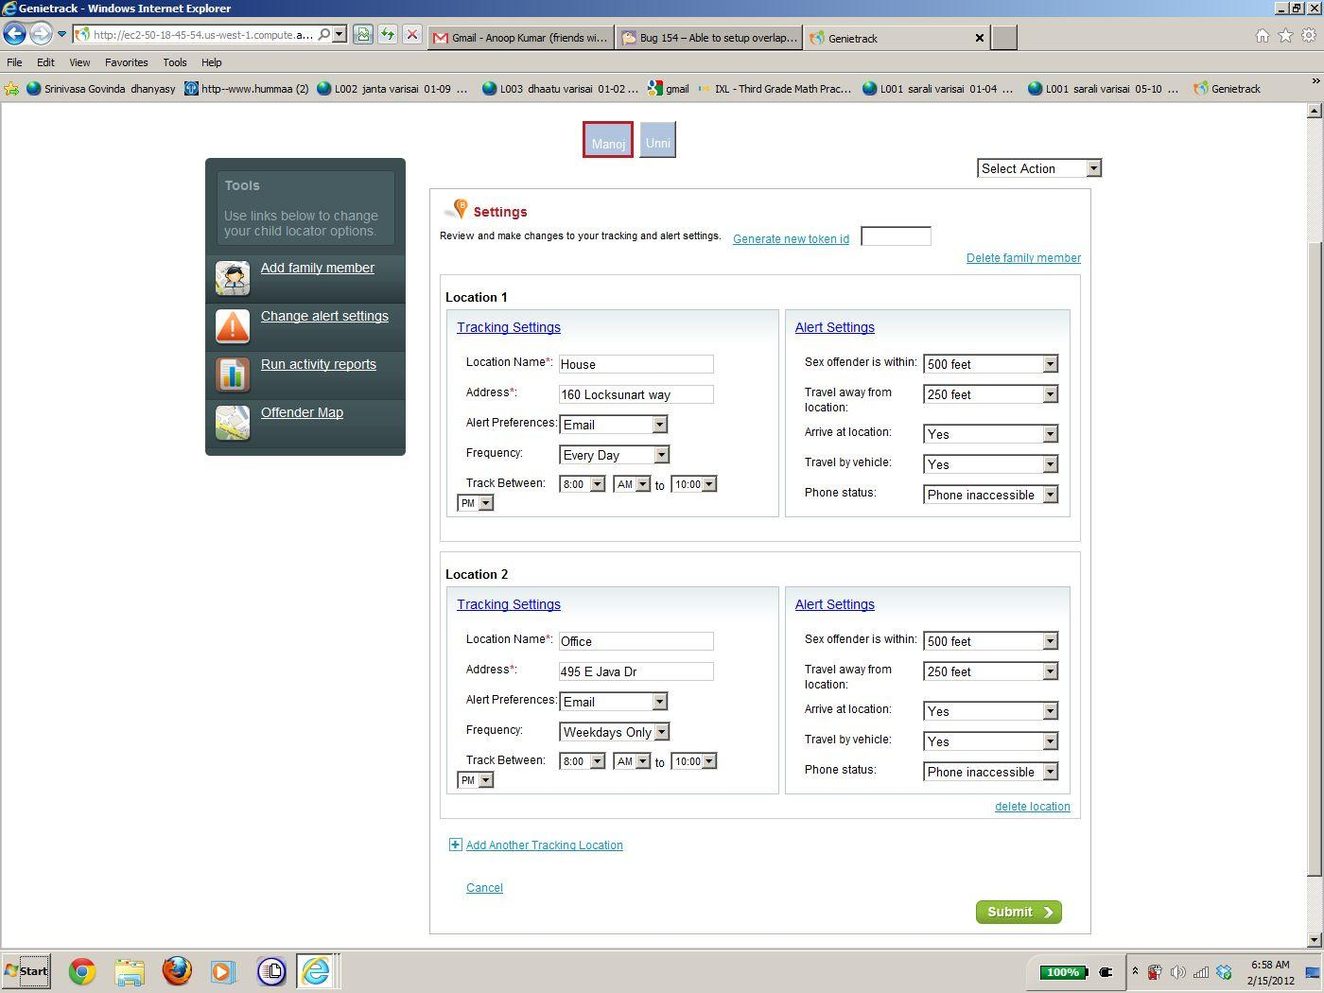

File Edit View Favorites Tools Help

se links below to theme 9 settings

**I our C I oca or Op Review and make changes to yourtracking and alert settings. Generate newtoken id**

Deiete familw member

Fg Add famil membe

Location 2 Tracking Settings Alert Settings

Location Name‘: Sex offender is within: [500 feet vl Address‘: 495 E Java Dr Travel awayfrom [250 feet vl location:

**Alert Preferences:| Ema“ vl Arrive at location: I-YE Frequency: Iweekdays Onlyj Travel by vehicle: Yes 7**

El Add Another Tracking Location